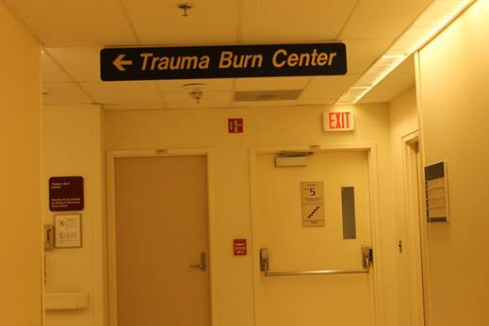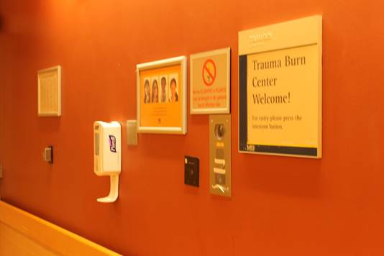

**Use the Intercom!**

**Or call 936-9673**

**To let us know you’re here!**

**WHERE:**

**The Burn Lab**

**When:**

**April 26th 2017 11 am – 1 pm**

**Come See What We Do with a 5 minute Tour!!!**

**?Questions?**

**Contact: Amy Drouillard** [**amydr@med.umich.edu**](mailto:amydr@med.umich.edu) **or Ninive Costa** [**costan@med.umich.edu**](mailto:costan@med.umich.edu)

**TOUR THE BURN LAB!!**

**APRIL 26th 2017**